The Unofficial Guide to Scoutbook for Parents and Leaders



Issaquah Valley, photo by the author.

Written by Andrew Burns, Pack 639   
Issaquah VFW (Sunset/Cougar Ridge Elementary) October 2015  
Revision 2.0 – October 2018

Table of Contents

1. Introduction 2

1.1 What is Scoutbook? 2

1.2 About this Manual 2

2. Using Scoutbook for Parents and Older Scouts 3

2.1 System Requirements 3

2.2 Initial Login 3

2.2.1 Troubleshooting Login Issues 3

2.3 Navigating Scoutbook 4

2.4 Viewing Progress and Checking off Requirements for Achievements and Electives 9

2.5 Service Log, Camping Log and Hiking Log 16

2.6 Sending Messages 16

2.7 Pack/Den Calendar 17

2.8 Subscribing to the Pack/Den Calendar Details on your Smartphone 20

2.8.1 Apple Devices: 21

2.8.2 Android Devices: 24

3. Scoutbook for Leaders 26

3.1 Understanding Permissions 26

3.2 Managing Permissions 26

3.3 Adding a Scout or Leader (New to Scouting) 27

3.4 Adding a Scout/Leader with an Existing Scoutbook Account (Transfers) 30

3.5 Sending Messages to a Specific Den/Patrol 31

3.6 Adding/Editing Calendar Events 31

3.7 Quick Entry Features 33

3.8 Creating a Den 34

3.9 Transferring a Scout between Dens 34

3.10 Advancement Sync Troubleshooting 35

3.11 Approving/Awarding Advancements 35

3.11.1 Needs Approval Report 35

3.11.2 Needs Purchasing Report 35

3.11.3 Needs Awarding Report 36

3.12 Report Builder 36

# Introduction

## What is Scoutbook?

Scoutbook is a website that tracks your Scout’s progress towards requirements for awards and ranks Scouting. Historically we used spreadsheets and signoffs, but this new system makes it easy to record progress, and for leaders to ensure your Scout gets recognized for their work. It also allows the leaders to develop plans for meetings and outings to ensure everyone is on track for achieving rank.

Scoutbook is also directly linked to BSA’s advancement tracking database, meaning that all of a Scout’s progress is tracked and portable between Scouting organizations, which can be helpful in the event you relocate to a different area.

In addition, Scoutbook also has a calendar and RSVP functionality that can be used to schedule events and manage sign-ups. There are also functions to record the hikes and camp-outs your Scout has attended.

## About this Manual

This manual is designed to assist parents and leaders in using Scoutbook and most of its features. There are two major sections of this manual – the first focused more on parents and older Scouts who will be using Scoutbook for advancement tracking. The second section of the manual is geared towards leaders and committee members, with more details on features specific to them.

It is written by a Cub Scout leader, so the terminology is geared towards Cub Scouts, but the site is virtually identical for Scouts/Venturers/Explorers.

I have no association with Scoutbook other than as a user. Scoutbook trademarks, designs, and forms are the property of Scoutbook, and I have no responsibility for the design or function of Scoutbook.

It is a work in progress and suggestions and comments are always welcome. It is copyright the author with all rights reserved. Permission is granted to any Scouting organization to reproduce or modify this document for non-commercial purposes with attribution to the author. For all other uses, please contact the author.

The latest version of this file is always available at:

<https://github.com/mrburnsns/UnofficialScoutbookManual>

Happy Scouting!

Andrew Burns

# Using Scoutbook for Parents and Older Scouts

## System Requirements

The site is geared towards mobile phones and tablets, but will work just fine on any computer. All browsers are supported, but cookies must be enabled.

## Initial Login

In virtually all cases, a Scoutbook account will be created for you by a Scoutbook administrator. You’ll receive an invitation email with a temporary password. Click the link in the email or navigate to [www.scoutbook.com](http://www.scoutbook.com). You should login with your temporary password, which you will be asked to change when you first login to the site:

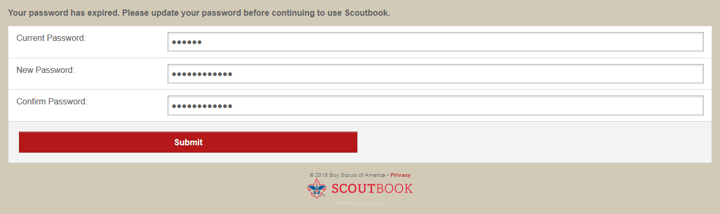

When you click *Submit*, you will be taken to your Profile page. To view your Scout’s info, click the *My Dashboard* button () ), then click the *Administration* link on the page that appears and your Scout’s information will appear:

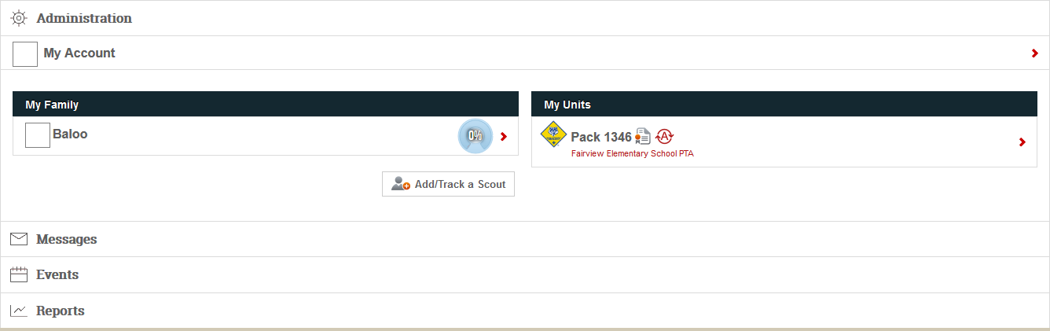

See section 2.3 for details on navigating Scoutbook.

### Troubleshooting Login Issues

If you have problems logging in, the site will display an error message. Common errors are usually resolved – just follow the steps below. If these steps don’t resolve the issue, contact your leader for further assistance.

Error 1: “Please refresh the page and try again.”

This error occurs when cookies are disabled. Scoutbook will not function with cookies disabled – you must turn on cookies for [www.scoutbook.com](http://www.scoutbook.com).

Error 2: “Username/password not found.”

Step 1: Double check that password has been typed correctly (note that Scoutbook passwords are case-sensitive).

Step 2: If you copy/pasted your temporary password, try typing it in manually and verify there are no leading or trailing spaces.

Step 3: Verify you have the correct password – if you had problems and requested a new password from the site, only the latest password will allow you to login.

Step 4: Try a different machine – if you are still having trouble with the initial login on a desktop computer, these issues can sometimes be resolved by logging in on a smartphone or tablet.

## Navigating Scoutbook

When you login to [www.scoutbook.com](http://www.scoutbook.com), you’ll get this screen:

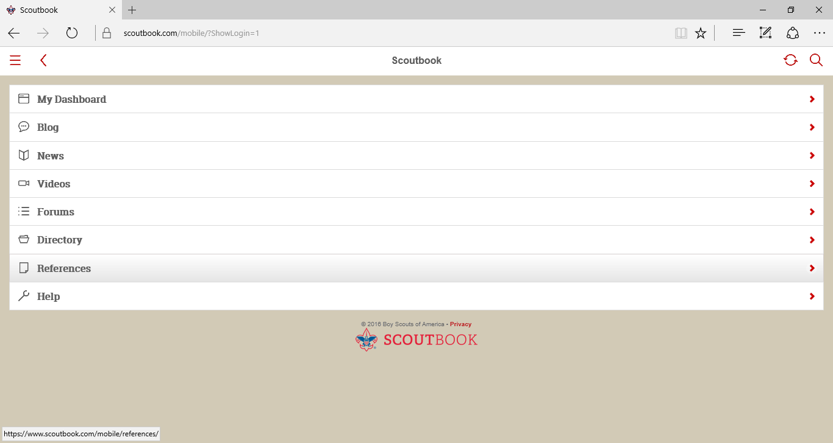

Choose *My Dashboard*. You’ll then move to a screen where you can see your Scout’s information:

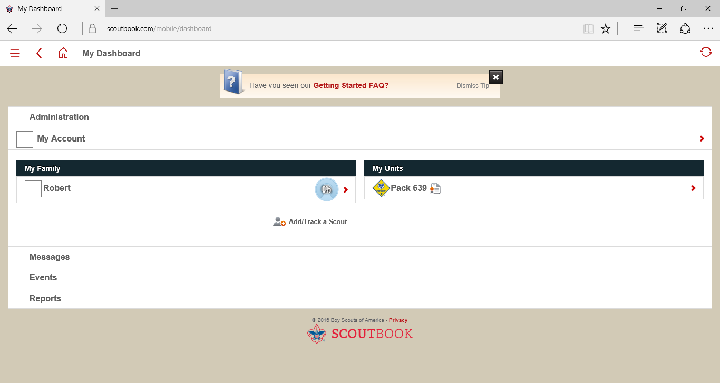

Note that you can always return to this page from lower level pages using the button at the top of the page.

Selecting *My Account* allows you to edit your own information:

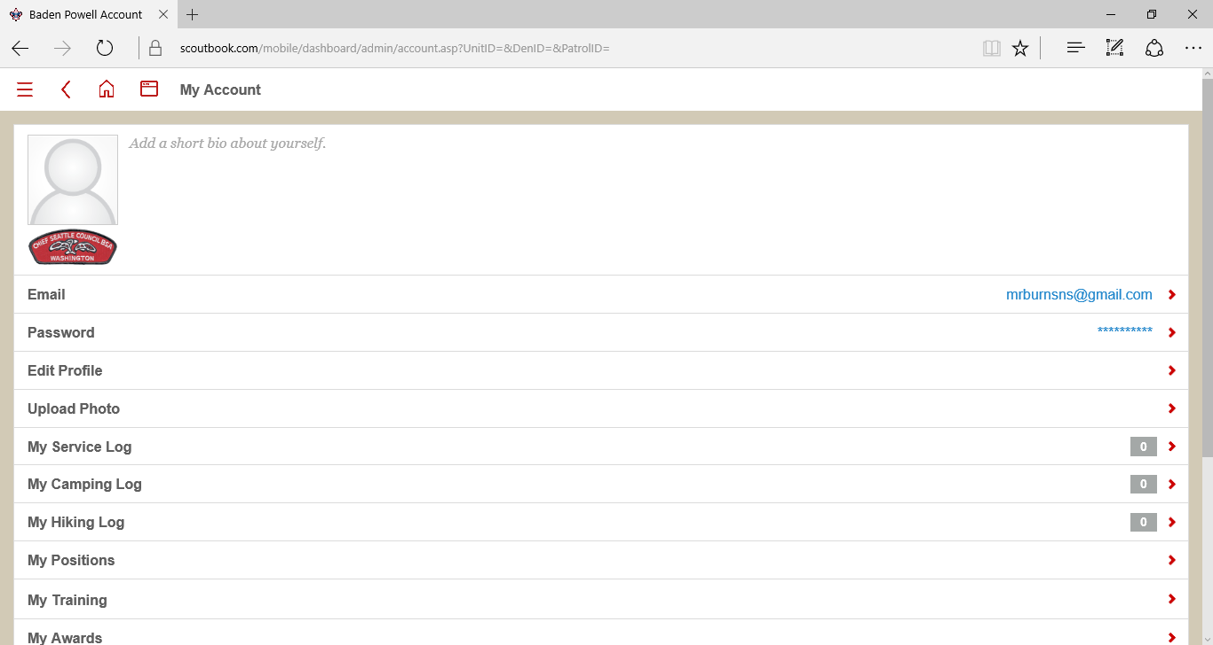

You can change your email and password using the *Email* and *Password* links. If you click *Edit Profile* you can also record your contact details and information:

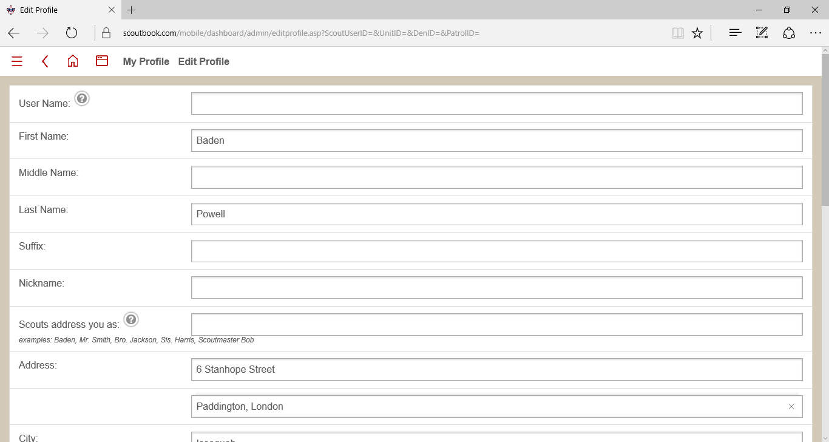

You can share as much or as little information as you choose on this page. On the dashboard page you can also edit your Scout’s information in the same way by clicking their name and then selecting *Edit Profile* on their profile page*.*

You can also choose to upload a picture of yourself or your Scout. From your profile or your Scout’s profilepage, select the *Upload Photo* link. This will allow you to browse to a photo stored on your device and upload it to the site. Note that it must be in JPEG format. When you upload a photo you’ll be able to pan, zoom and rotate as necessary:

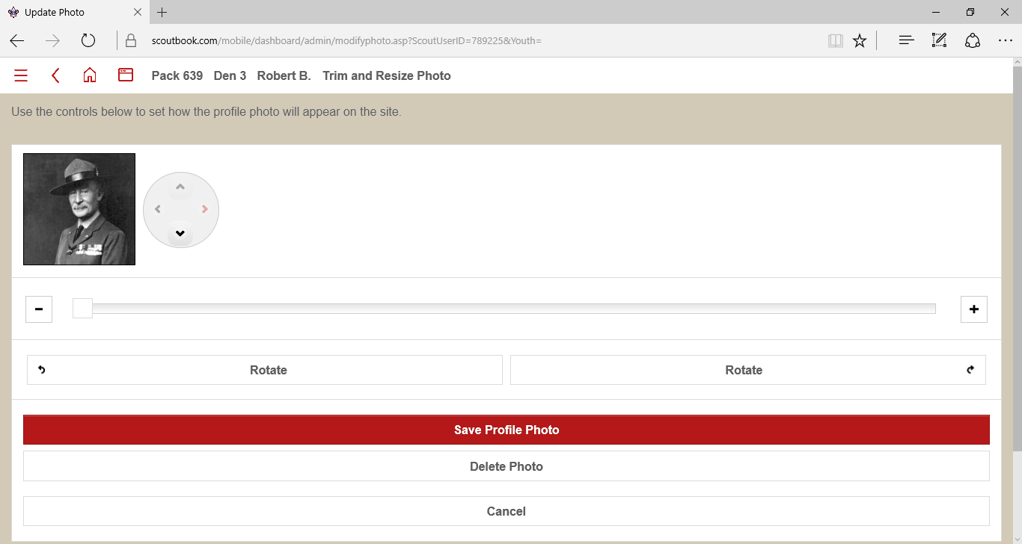

On your Scout’s *Edit Profile* page you’ll also have one additional option – you can *Invite* your Scout and then they will be able to login to the site on their own. If you wish to take advantage of this option it’s located at the bottom of your Scout’s *Edit Profile* screen. They will need an email address of their own if you wish to use this feature. They will receive a unique password, and control over their advancement and profile. When you click the *Invite to Connect* button, you will be prompted for your Scout’s email.

## Adding Parents or Guardians to Scoutbook

Usually the parent listed on the BSA registration form will be the parent initially connected to the Scout. However it is often helpful to have a second parent, other family members or guardians with access to Scoutbook. To add a new connection, go to the Scout’s profile and scroll down to *[Scout’s Name] Connections* link towards the bottom of the page:



This will bring up a page that displays the Scout’s current connections. Click the button marked *Add* to create a new connection. A new page will appear:

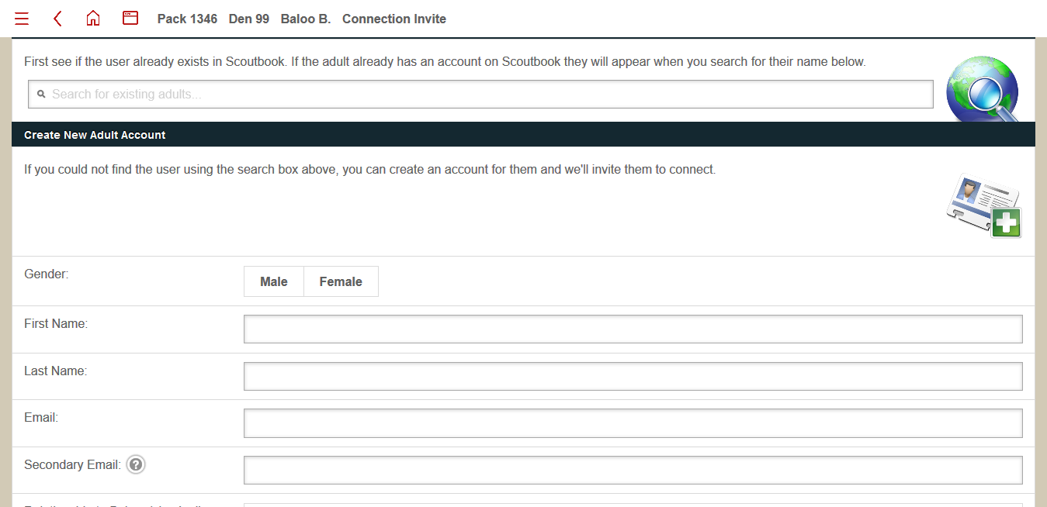If the new connection has a Scoutbook account, you can search for them by first and last name in the field at the top of the page (unfortunately there is no search by email). If you find the person, click their name, which will turn off most of the fields (since the information is already in their Scoutbook profile). If not, enter first and last name, plus at least a primary email address.

Regardless of whether the parent has an existing Scoutbook account or not, you will need to correctly set the relationship and permissions level for the new connection. For parents/guardians, check the *Parent* box and turn on the *Full Control* switch: 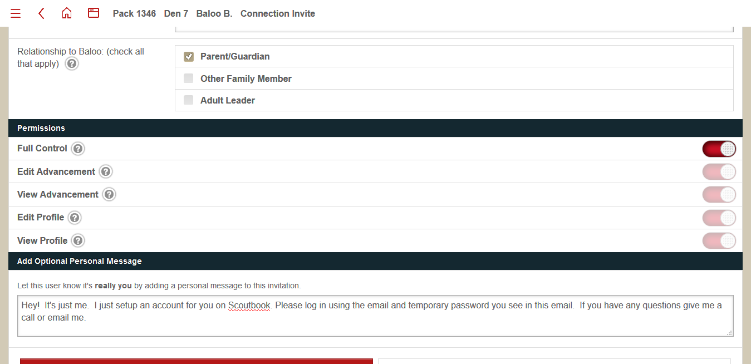For other family members, you can grant access as you see fit.

Continue scrolling and you will see an *Invite* button, which will send an introductory email and temporary Scoutbook password to the new connection. They will receive the following email (login and password have been obscured with a white block):

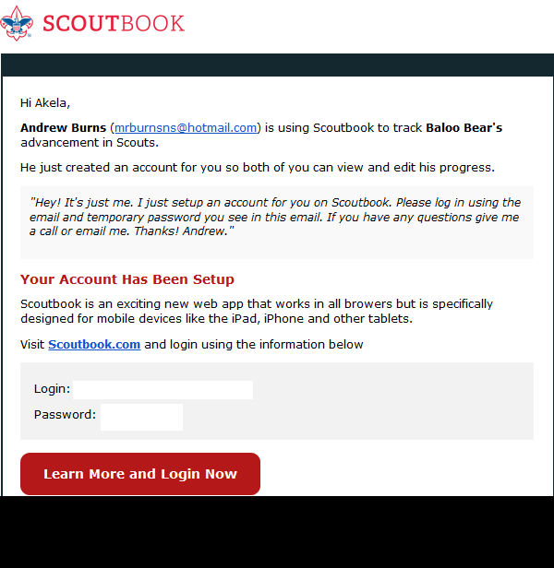

They will then need to login to Scoutbook and set up their profile. The method is the same as described in Section 2.2 for the initial parent account.

NOTE: Any Connections added after a Scoutbook Calendar event has been created will not be added to the invitee list automatically and will not receive reminder emails. When adding a new connection please let your Scoutbook administrator know so they can ensure the new connection is added to existing events.s

## Viewing Progress and Checking off Requirements for Achievements and Electives

From *My Dashboard***,** click your Scout’s name to bring up their record:

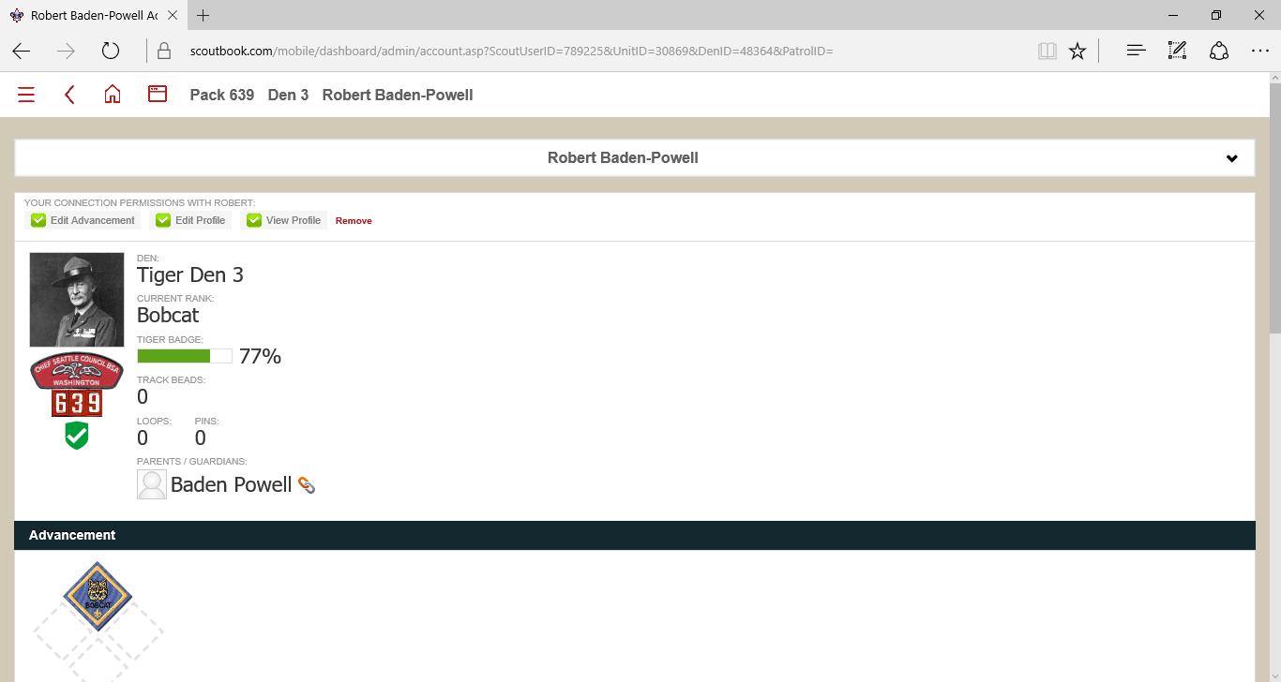

At the top you’ll see some basic information tracking your Scout’s progress, but the most useful features are down a bit further. Under *Advancements* and *Awards* you can see all of the awards your Scout has already received:

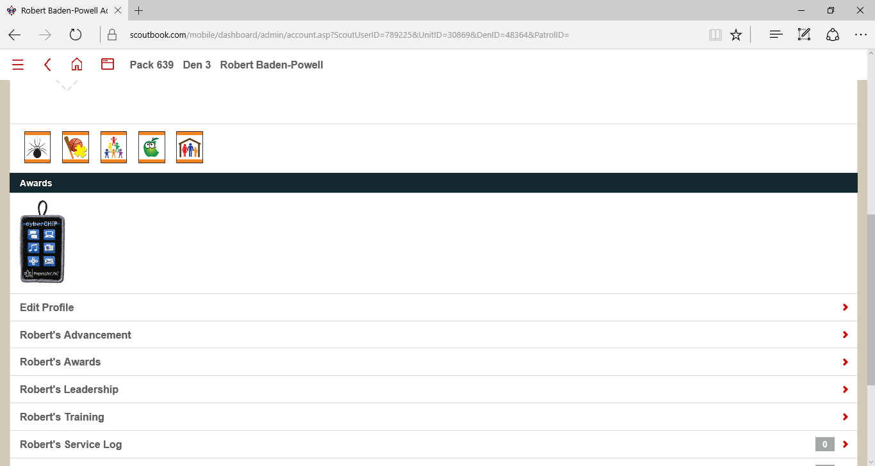

Further down you’ll see a number of links:

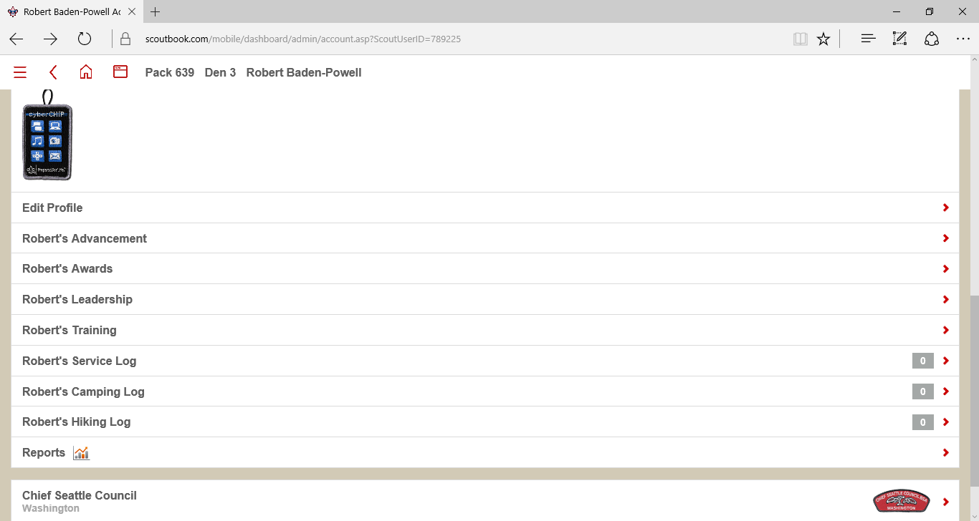

You can edit the information under all of these links.

The *Advancement* linkis the one you will use most frequently. It allows you to indicate to us that your Scout has completed some or all of the requirements for an Acheivement or Elective outside of a meeting or outing. It also shows you the progress towards each Acheivement and Elective so you can see where your Scout might need to do only one or two things to receive a belt loop. When you select the *Advancement* link, here’s what you will see:

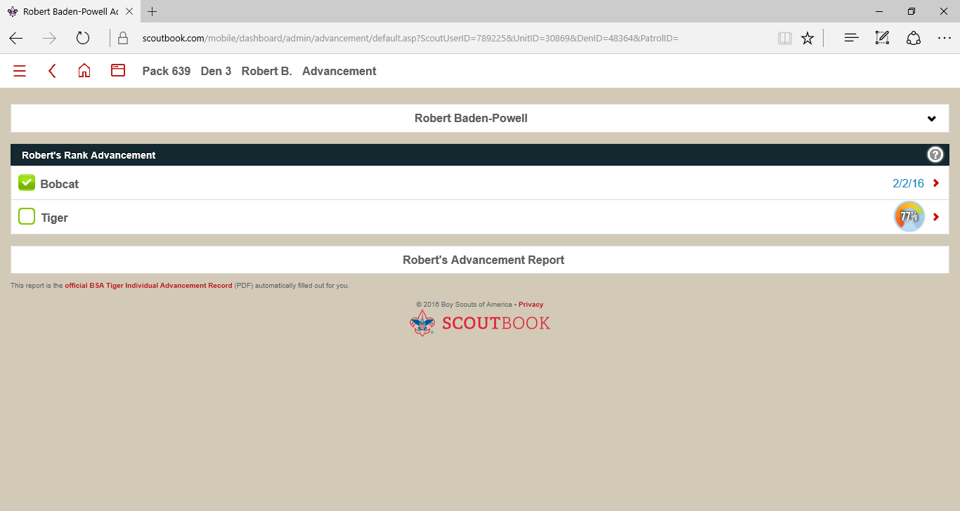

As your Scout advances, Scoutbook tracks their progress from Bobcat onwards. Click the rank your Scout is currently working on to bring up a new page:

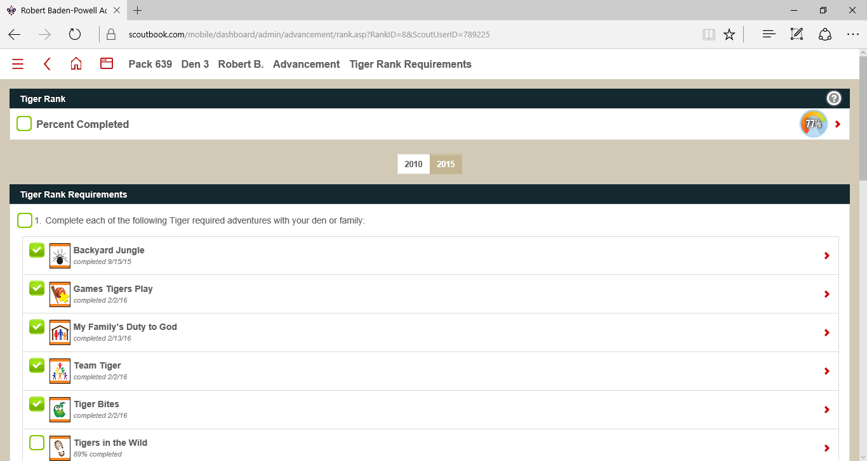

They are split into rank Requirements (Acheivements) and Electives, but both work the same way. Note that each Achievement and Elective will show percentage complete if they have not yet been awarded. When your Scout completes a requirement, select the appropriate belt loop. This will bring up a new screen:

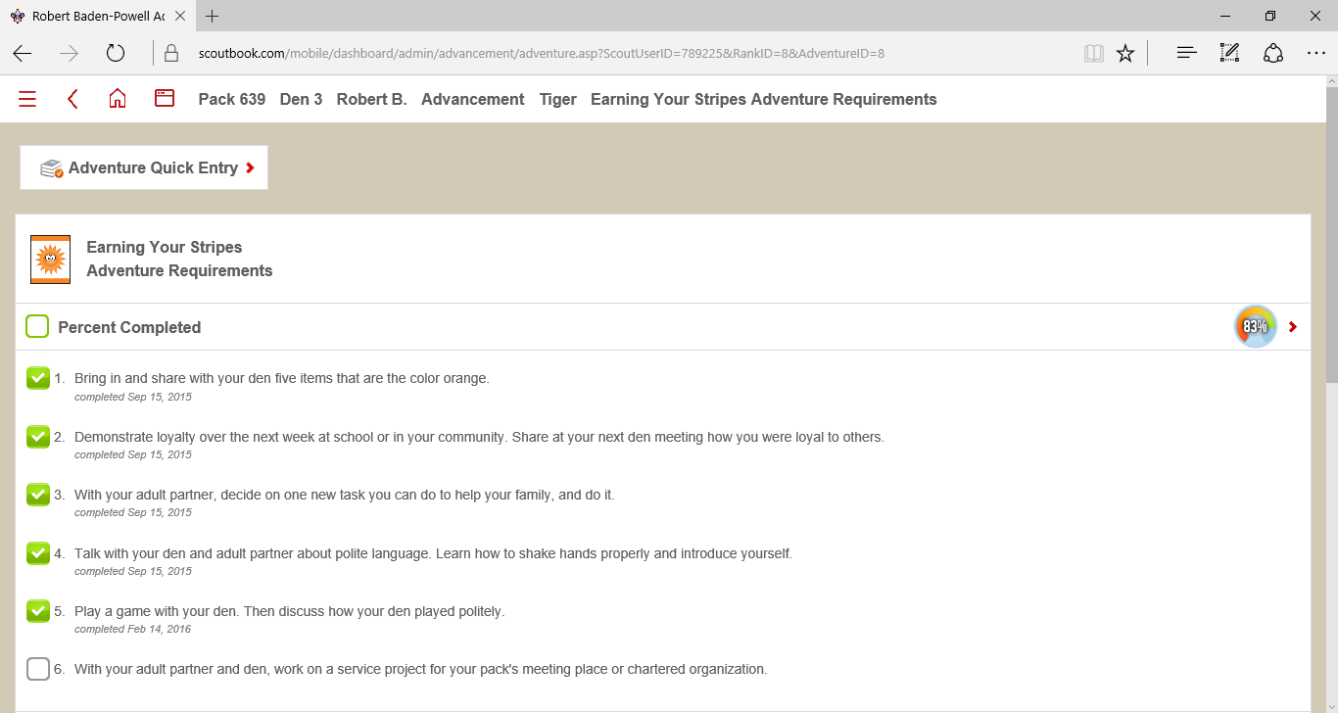

If you scroll down, you will see a section to add comments for your own reference and for leaders to view.

When a requirement is completed, check the box of the requirement you have completed. This will bring up another screen allowing you to record the date:

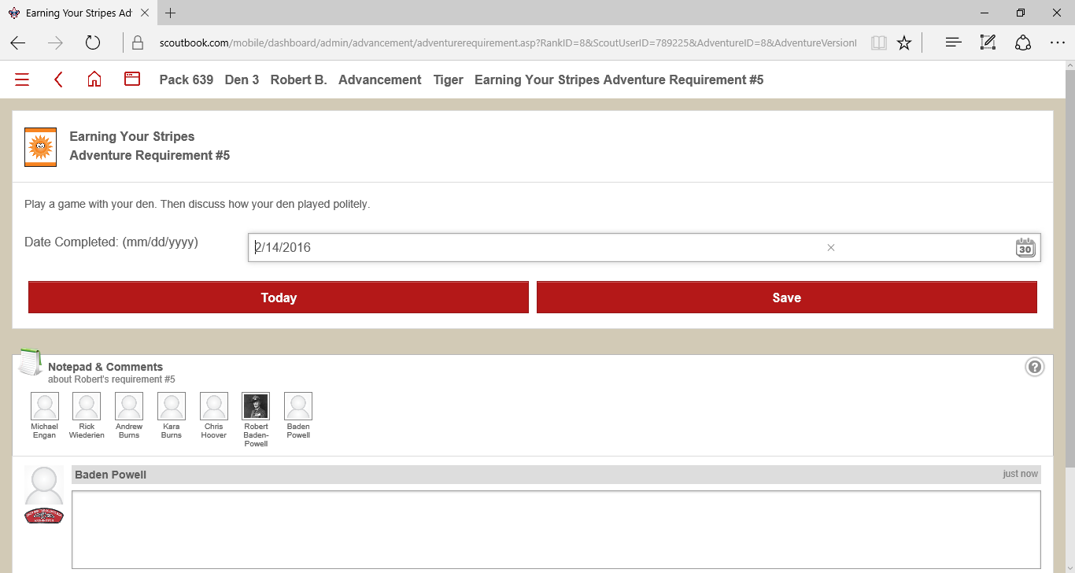

Just hit the *Today* button to mark completed as of today’s date – or enter a date and click *Save*. If you mark an item complete by mistake, just delete the date and click *Save* to erase the checkmark. When you mark an item complete, it notifies the leaders, and if your Scout has completed an Achievement or Elective we can make sure your Scout gets their award. Again you can add comments for your reference and for the leaders to see at the bottom of the page.

Checkmarks and boxes have the following color code:

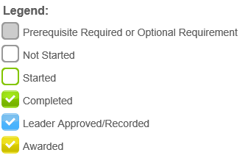

If your Scout has completed multiple requirements for a belt loop, you can use the *Adventure Quick Entry* screen. Select the link at the top of the page after selecting the belt loop:

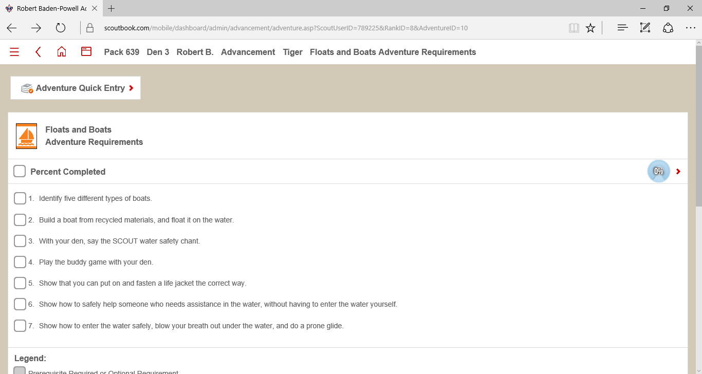

This will bring up a new screen:

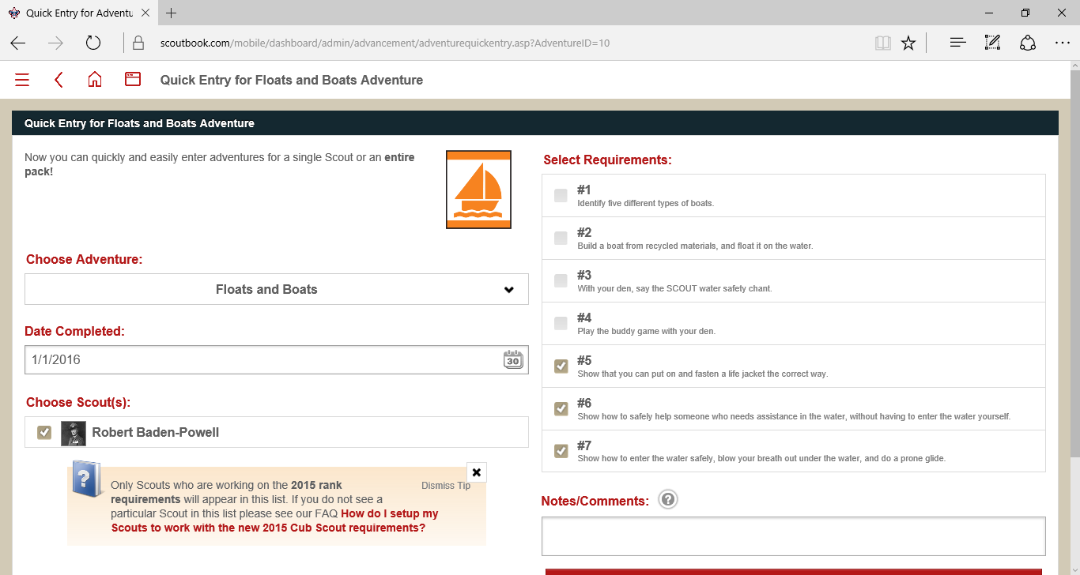

Simply enter the date the items, check the box for your Scout, check the boxes for the requirements completed and provide any comments. Below the comments section you will see a *Submit* link which will update your Scout’s record.

The *Awards* link functions in the same way – select the award your Scout has completed a requirement for outside of a den or pack event, and enter the date of completion and any comments.

When you mark requirements for belt loops and awards, the leaders are automatically notified so that they can approve the changes and award your Scout in a timely manner once all requirements are met.

## Service Log, Camping Log and Hiking Log

These links allow you to record your Scout’s service hours, camping trips and hiking mileage within Scoutbook. When you click one of the links, it will display all previous entries. Click an entry to add/view the entry, and click *Add* to create a new entry:

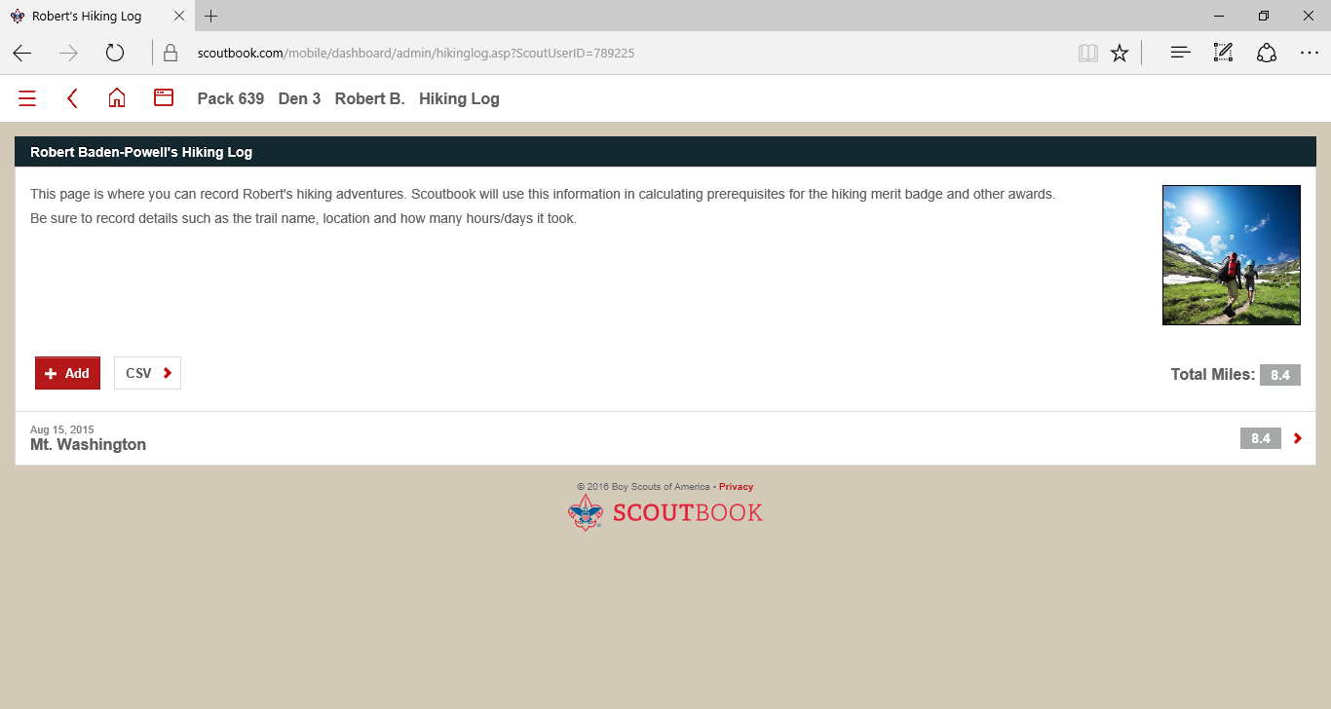

When you click *Add* or click an existing entry, you’ll be taken to a new screen where you can record relevant details and any comments. As an example, here’s the entry screen for a Hiking Log entry (the Service and Camping versions are similar):

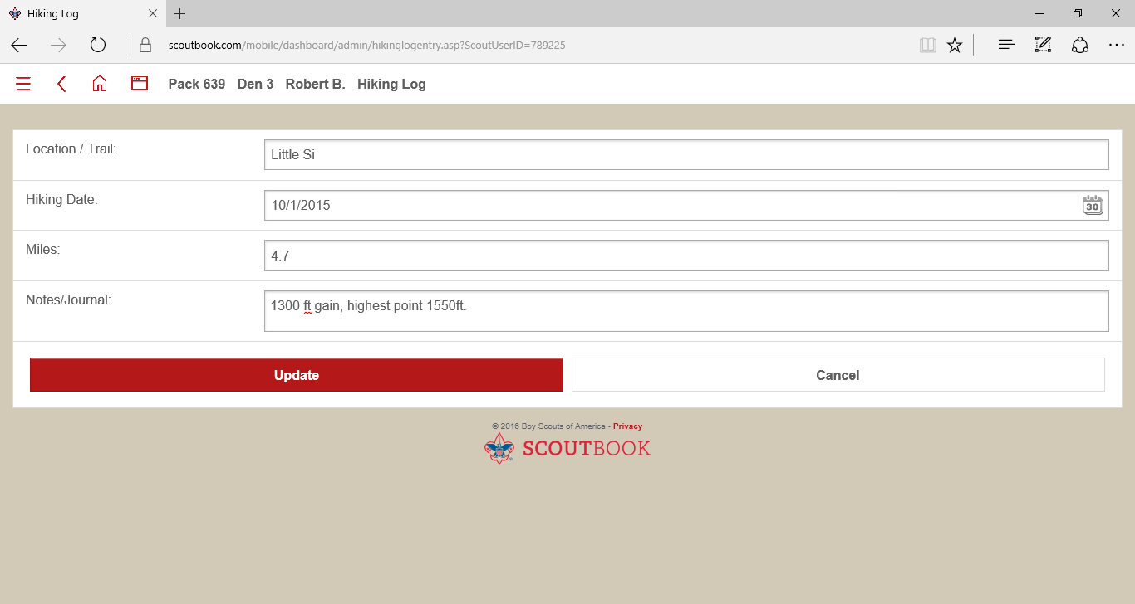

## Sending Messages

To send a Message from Scoutbook, click on the *Messages* link in *My Dashboard. This will bring up a new dialog:*

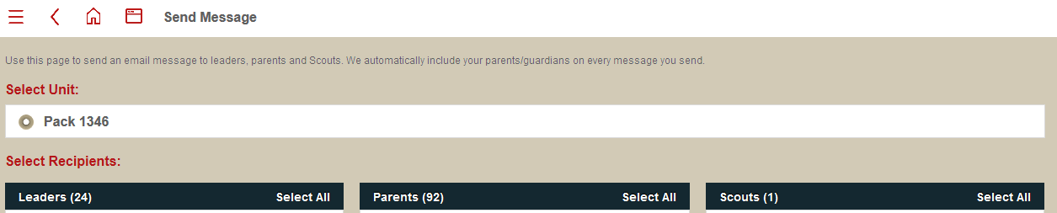

Under Leaders, Parents and Scouts, you will see an entry for each profile of that type in the Pack/Troop. You can choose to Select All to send a message to everyone in the group, or click an individual name or names to send a message to a select number of people. When you select a person to add to the message their name will be highlighted in yellow with a checkmark next to it as shown below:



Message content and attachments are specified below the list of people associated with the unit:

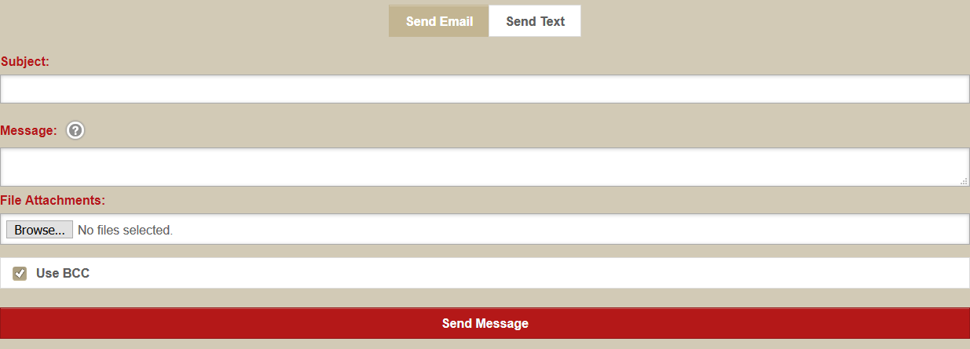

The *Use BCC* checkbox blind carbon copies all recipients, so that only the sender is visible. Once the message is complete, clicking *Send Message* sends the message to the selected recipients.

NOTE: If a Scout is sending a message, the Scout’s parents are copied on that message automatically. This setting cannot be overridden (as it is required to comply with BSA’s Youth Protection guidelines).

## Pack/Den Calendar

If you return to the My Dashboard page, towards the bottom of the page you will see links that allow you to see upcoming events:

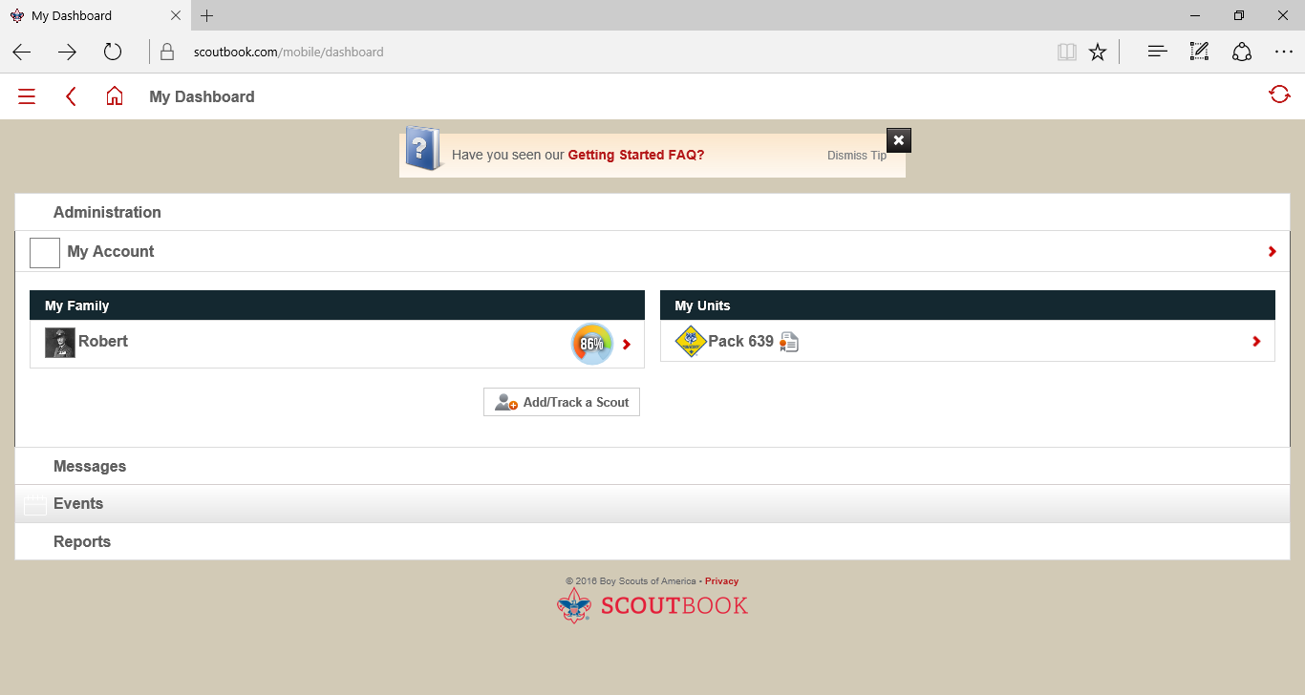

On the next screen, you will see a number of *Upcoming Events* links that you can click to take you directly to that event’s page. You can also click the *My Calendar* link to bring up the combined pack and den calendars.

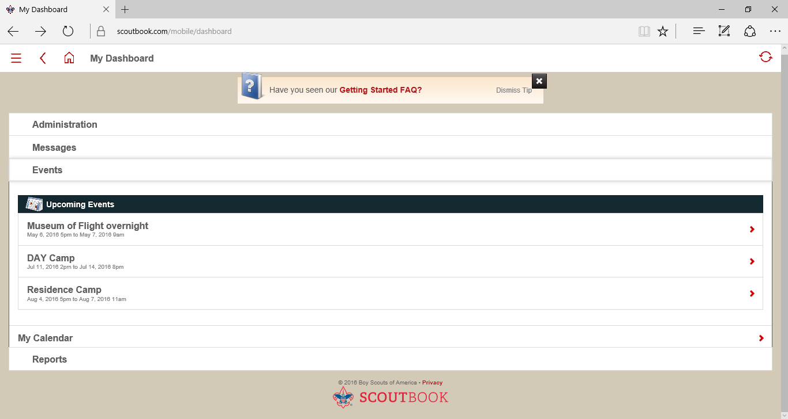

The *Calendar* page shows upcoming events in calendar format and below in a list format. You can click the link in the calendar or below to see more details about an event. You can advance the month using the arrows around the currently viewed month, and the year using the arrows around the currently displayed year.

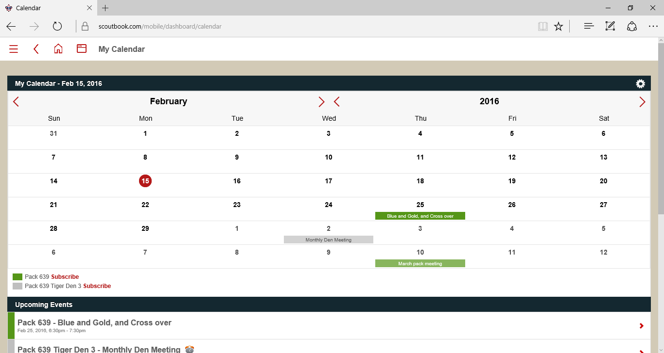

When you click on an event page, you’ll see the following: 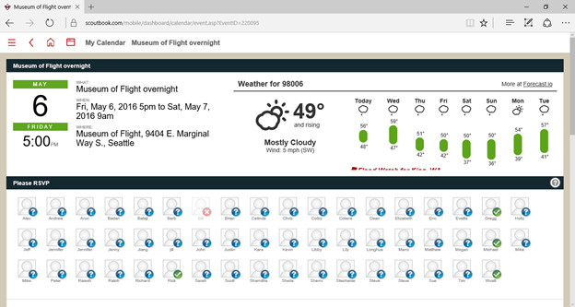

The top of the page has all event details, including time, weather and location. If an event requires an RSVP, you will see *Please RSVP* below the event details. Blue *?* indicates that the person is a maybe or has not yet replied, with green checkmarks indicating the person plans to attend, and red *X*’s indicating that person has declined. To RSVP, click your photo or your Scout’s photo, which will bring up three buttons:

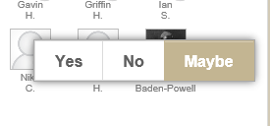

By default you are marked as a *Maybe* when the event is created. To accept, click *Yes*. To decline, click *No.* To change your RSVP, just click your picture again and choose the appropriate button. You can also post/view comments at the bottom of the event page that will be visible to all invitees.

## Subscribing to the Pack/Den Calendar Details on your Smartphone

You can add details from the pack and den calendars to your Apple or Android device. You’ll see *Subscribe* links at the bottom of the calendar display:

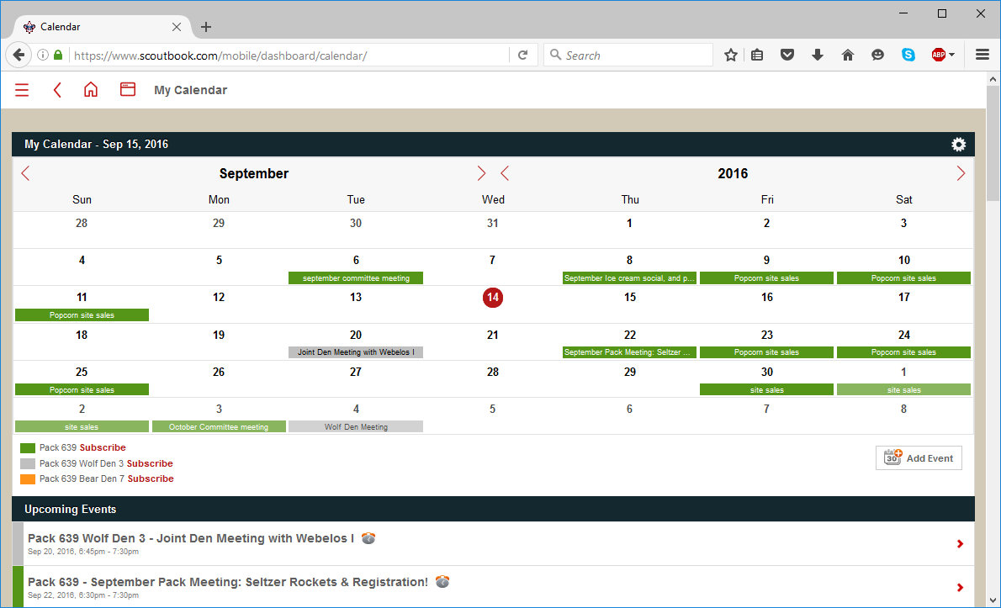

This will bring up a window with a hyperlink to the .ics file of the calendar:

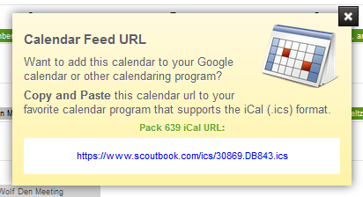

Copy the link, and then follow either the Apple device or Android device instructions below. You’ll need to repeat the process for each Pack/Den calendar you wish to add.

### Apple Devices:

You can subscribe to the calendar by opening your device’s *Settings* menu. Scroll to *Mail, Contacts, Calendars and click.*

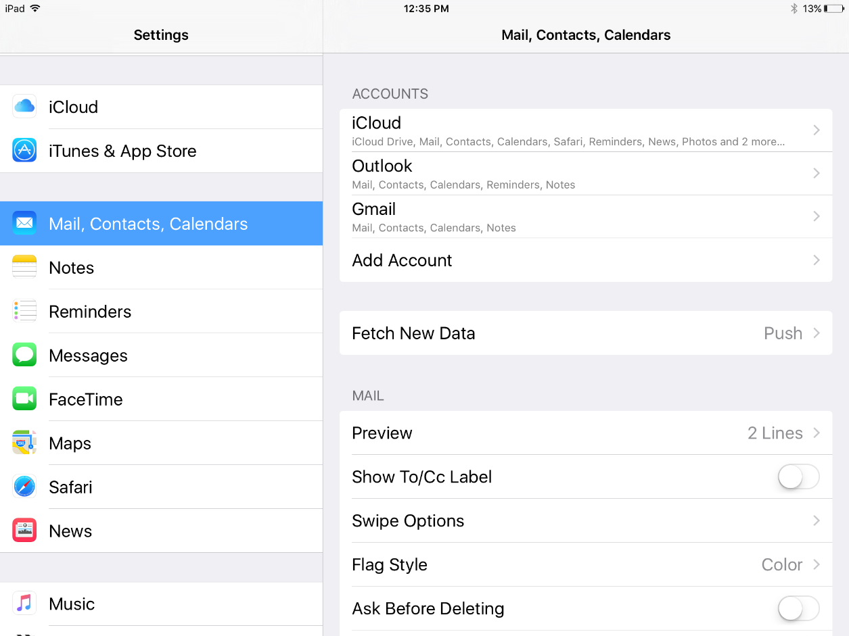

Select *Other* at the bottom of the list that appears:

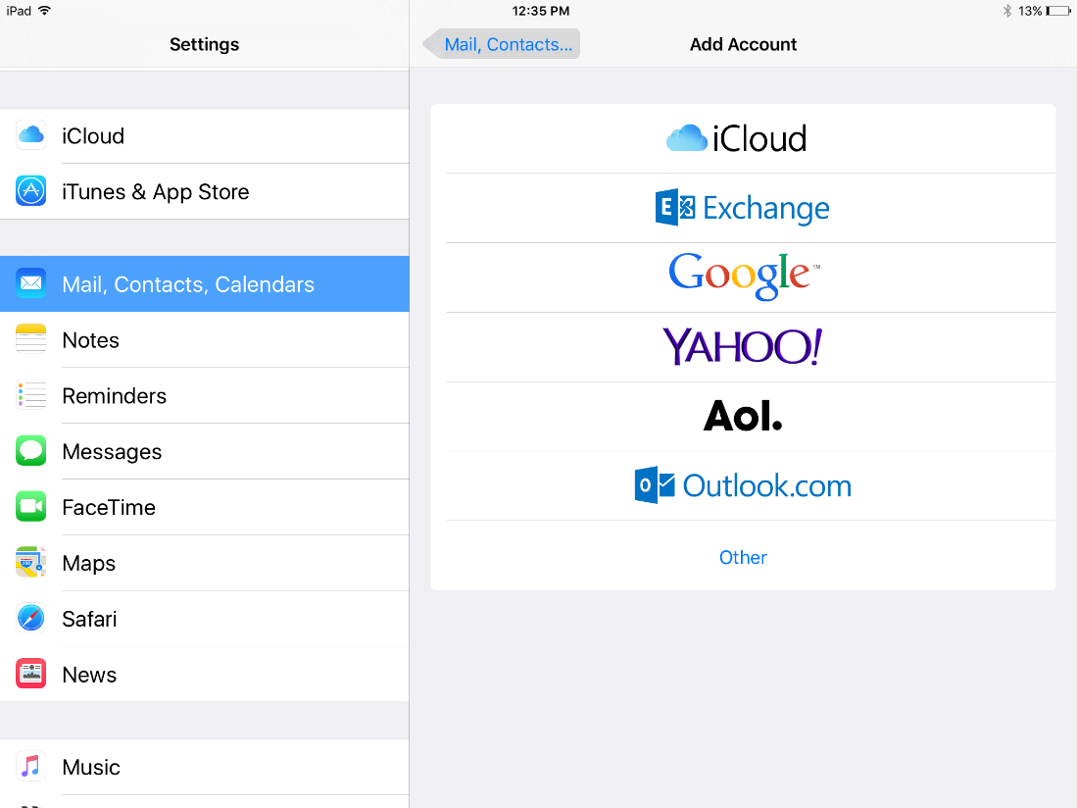

Select *Add Subscribed Calendar* on the menu that appears:

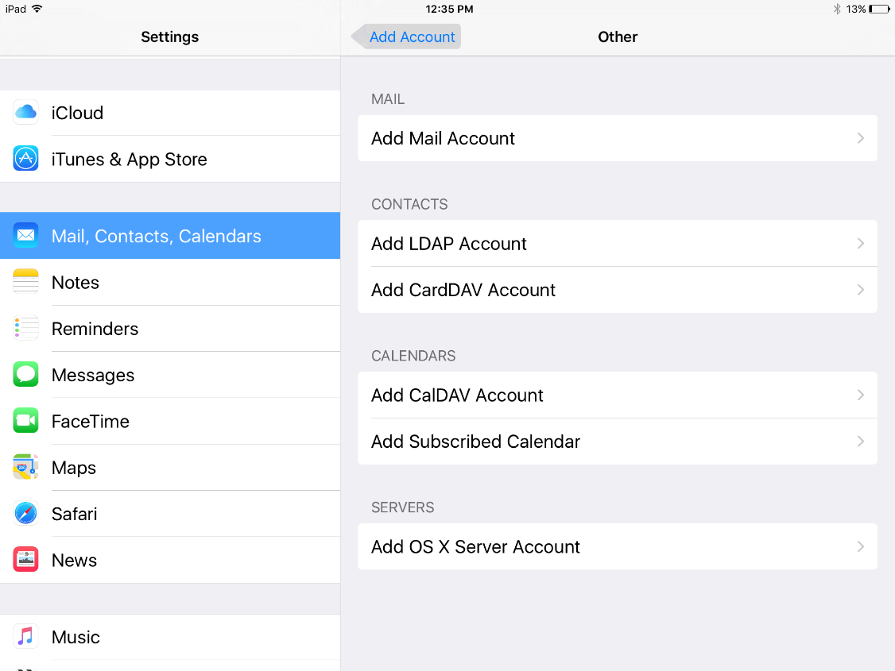

Paste the link you copied earlier from Scoutbook into the *Server* field and click the *Next* button:

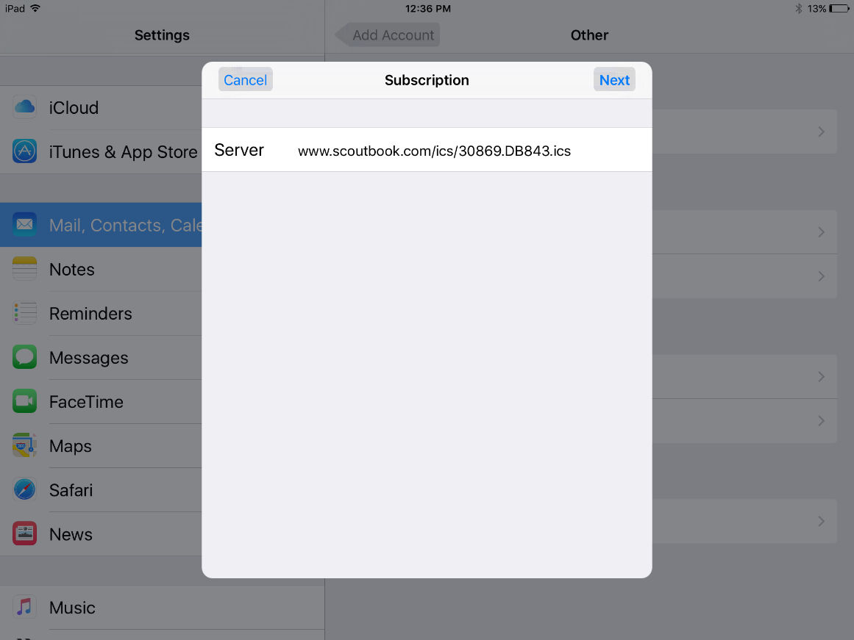

The details of the calendar will be downloaded – simply click the *Save* button and you are subscribed:

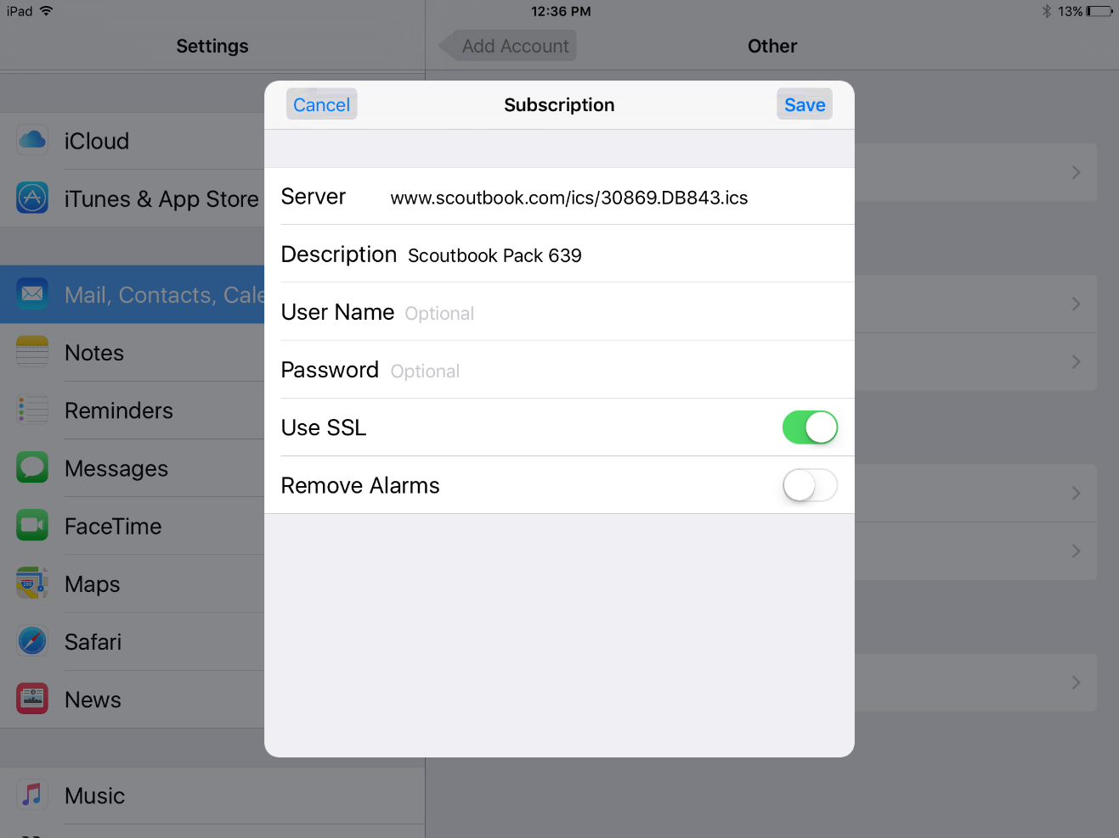

### Android Devices:

If you have an Android device, you can only subscribe to a calendar using the desktop version of Google Calendar. First browse to the Google Calendar site. Setting up a subscription is easiest to do on a desktop, but if you only have a tablet or phone, you must switch to the Desktop site on your device below before following these instructions (the stock Android and Google Calendar apps do not allow you to add calendar subscriptions). If you don’t have a desktop computer, you’ll need to switch to viewing the Desktop version of the calendar site. You can do this by scrolling down on the Calendar page and clicking the *Desktop* hyperlink:

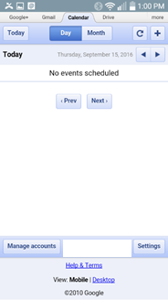

From then on, the instructions are the same, whether you are on a computer or mobile device.

To add the subscription, from the desktop calendar view, click the down arrow next to **Other Calendars**, then click *Add by URL***:**

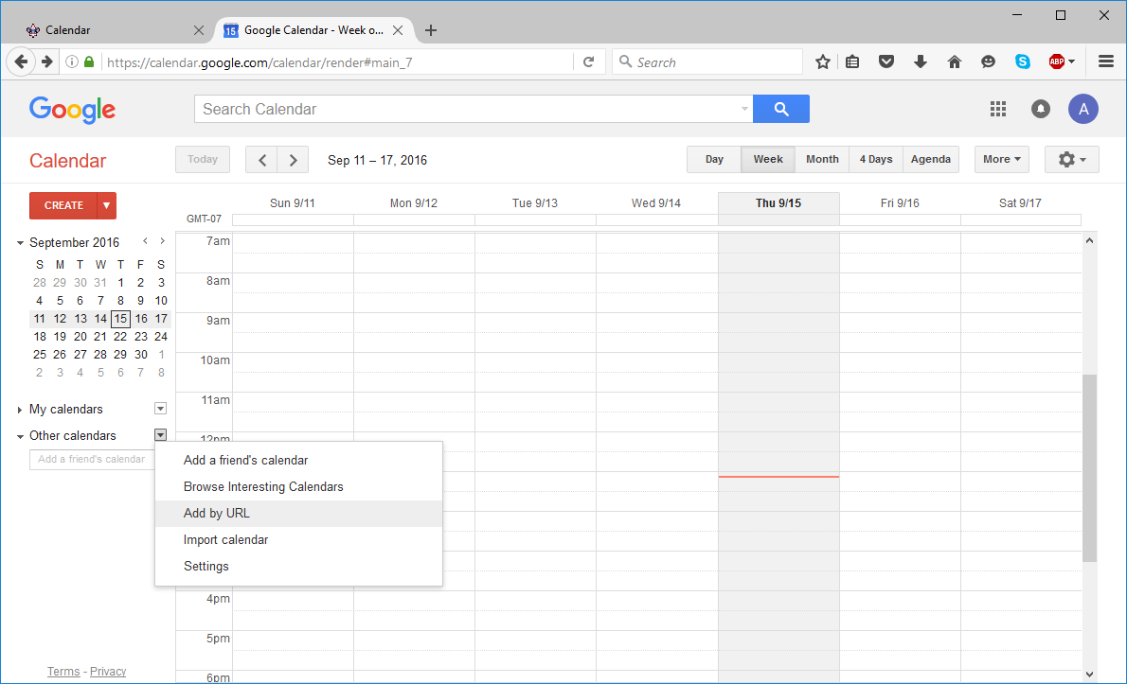

Paste the URL from Scoutbook, then click *Add Calendar*:

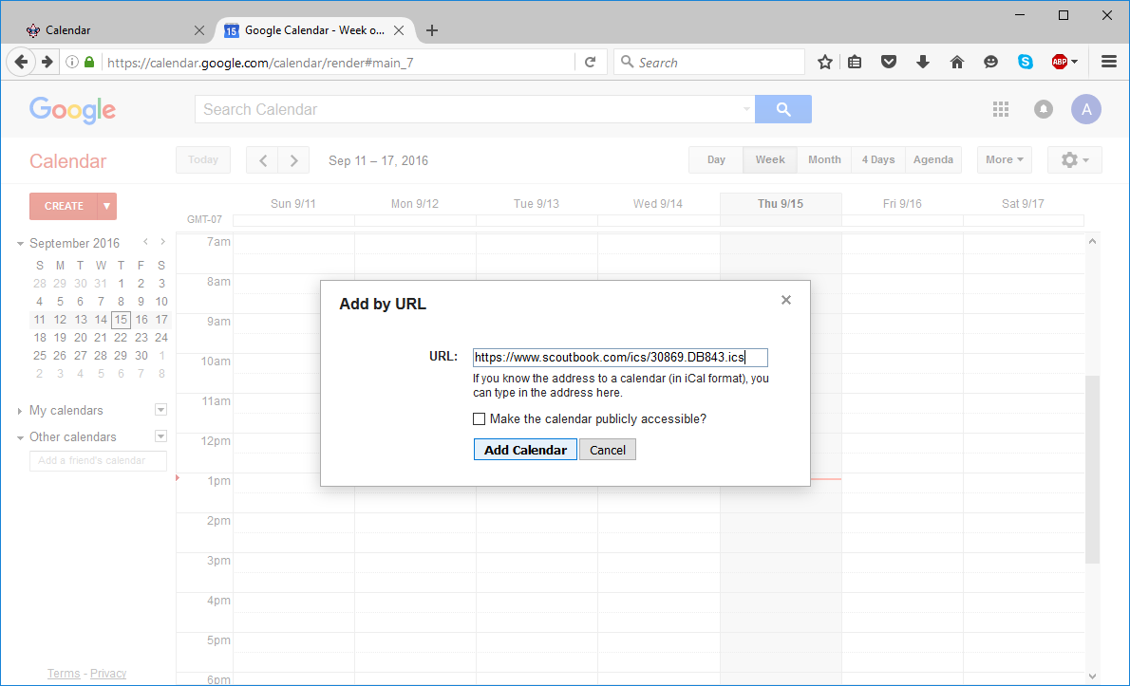

The events should then populate your calendar.

# Scoutbook for Leaders

## Understanding Permissions

One of the biggest headaches for new leaders and parents is incorrectly set permissions. There are several different permission levels within Scoutbook, and they can be set differently for each user for all parents, leaders and Scouts within a Pack or Troop:

View Profile

This allows view-only access to a particular profile.

View Advancement

This allows view-only access to advancement details for a particular profile.

Edit Profile

This allows the user to edit a particular profile.

Edit Advancement

This allows the user to edit advancement details for a particular profile.

Full Control

This allows full control over the profile and advancement of a particular profile. It is equivalent to having both Edit Profile and Edit Advancement permissions.

As a guideline, parents should be permitted Full Control over their Scout’s profile and advancement. Scouts may be granted view/edit permissions as appropriate for their age and needs.

From a Pack/Troop perspective, Den/Patrol leaders should be granted full control over the Scouts within their Den/Patrol. This is done by making them a Den/Patrol admin, and will be indicated in the roster with a single key icon next to their name ( ).

At the Pack/Troop level, Cubmaster/Scoutmaster, Pack/Troop Committee Members, Merit Badge Counselors and Scoutbook administrators should be granted full control over all the Scoutbook accounts associated with the pack. This is done by making them a Pack/Troop admin, and will be indicated in the roster with a pair of keys icon next to their name (. ).

## Managing Permissions

For a Scout’s connections, their permissions can be managed from the Scout’s profile. Simply click on their name in the roster, or the name of a connection within the Scout’s profile. Connections at the Den/Patrol Level can be managed using the *Connections Manager.* To use Connections Manager, navigate to the Den/Patrol level and select the *Connections Manager* link. This will bring up a matrix showing the names of the different accounts related to the Den/Patrol and their permissions over the Scout records within that Den/Patrol. These are indicated by circle icons in the matrix: 

To edit permissions, click the cell in the row where the person who requires control over the Scout’s account is listed in and the column the Scout is listed in intersect. This will bring up the following dialog: 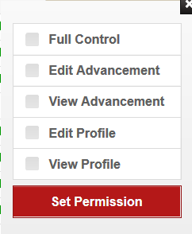

Select the appropriate options and click *Set Permission*.

## Adding a Scout or Leader (New to Scouting)

For a leader, simply click the *Add Leader* ( ) button on the Pack/Troop or Den/Patrol roster. Enter the leader’s details and email address and then select their position and Admin roles. Clicking *Invite* will process the changes and notify the leader.

To add a Scout who is new to BSA, simply open up the main Pack/Troop page or view the Roster for an individual Den/Patrol, then click the *Add a New Scout* button:

This will bring up a new dialog – enter the First/Last Name (as they are shown in the application form/BSA records) and basic information – zip code, den, birthday and gender, then click *Next*.

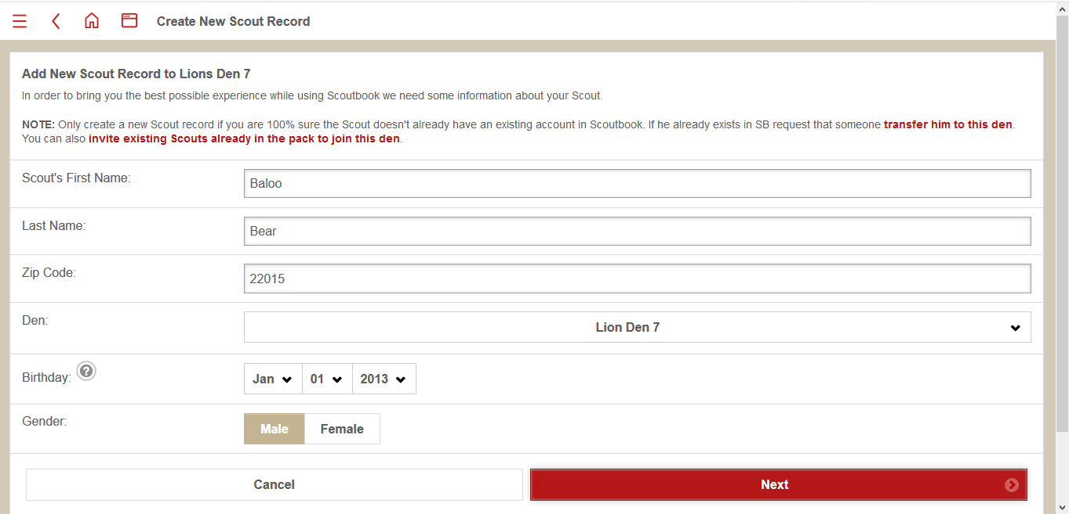

Complete the new Scout’s profile by navigating to their profile in the Pack/Troop Roster or Den/Patrol Roster and clicking their name in the list of Scouts. This will bring up their main Scoutbook profile. The first step is to go to *Edit Profile* and add the rest of the Scout’s information. You can complete as much or as little of this information as you want. The three most important fields are *First Name, Last Name* and *BSA Number*. These must match the same values for the Scout within your official BSA roster for advancement syncing to function properly. See Section 3.10 for additional help on Advancement Sync issues.

At this point, the Scout’s achievements and progress can be tracked, but in order for a parent/Scout to use Scoutbook, you must add connections to the profile. Den Admins and Pack Admins will be granted full control access when the account is set up, however, there are no parent/Scout access permissions created by default.

To permit a parent to access a profile and advancements, you must create a connection. To do this, go to the main profile page for the new Scout and click *Add Parent*. This will display a list of the Scout’s current connections (which should consist of pack and den leaders at this point). Clicking the *Add* button will display the following dialog:

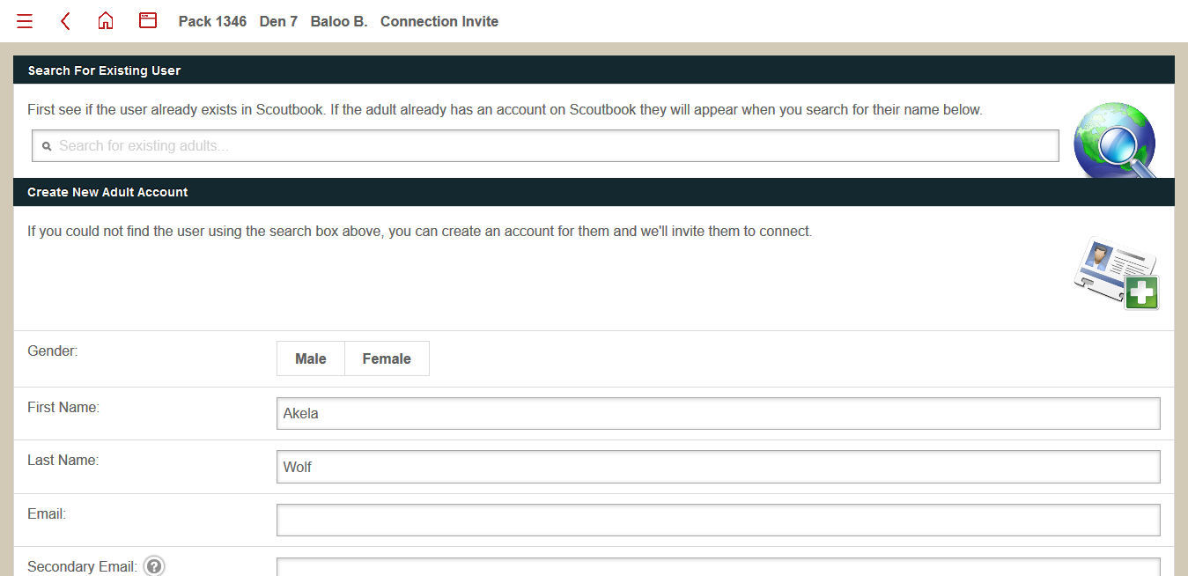

It is always good practice to search for existing Scoutbook accounts to prevent the creation of duplicate accounts. Search is only by first/last name and unfortunately not by email. If you find the person, click their name, which will turn off most of the fields (since the information is already in their Scoutbook profile). If not, enter first and last name, plus a primary email address.

Regardless of whether the parent has an existing Scoutbook account or not, you will need to correctly set the relationship and permissions level for the new connection. For parents, check the *Parent* box and turn on the *Full Control* switch: 

Continue scrolling and you will see an *Invite* button, which will send an introductory email and temporary Scoutbook password to the parent. They will receive the following email (login and password have been obscured with a white block):



At this point, the only remaining task is to enable BSA Advancement sync, which requires an existing BSA number and the Scout to show on your official roster. Some features around approval of advancements/awarding of advancements will be limited until this step is completed. See section 3.10 Advancement Sync Troubleshooting for more details.

## Adding a Scout/Leader with an Existing Scoutbook Account (Transfers)

If a Scout or Leader who is new to your pack/troop is transferring from another pack or troop, you will connect them to the pack.

For a leader, simply click the *Add Leader* ( ) button on the Pack/Troop or Den/Patrol roster. Search for the leader by name in the search field at the top of the page, and select their name. After you have selected the new leader, specify their position and Admin roles. Clicking *Invite* will process the changes and notify the leader.

Note that BSA numbers may change when transferring between councils, so you may need to update the new leader’s BSA number after their transfer is processed so that training and other information synchronizes with BSA’s servers. See section 3.10 Advancement Sync Troubleshooting for more details.

If a Scout is transferring from a different pack/troop, you will need to add one of the leaders in the new pack as a connection with Full Control permissions. Ask the Scout’s parents or former leaders to do this. Once you are connected, you can go to the Scout’s profile and update their Pack/Troop information. Note that in some cases, BSA numbers for transferring Scouts will change – you will need to update the BSA number once it has been issued by the new council. See section 3.10 Advancement Sync Troubleshooting for more details.

## Sending Messages to a Specific Den/Patrol

Message functionality for leaders works the same as for parents and Scouts, as described in Section 2.7 Sending Messages. The main difference is that leaders can preselect leaders/parents/Scouts associated with a particular Den by browsing to that den’s profile and selecting the *Send Message* link.

## Adding/Editing Calendar Events

To add calendar events, go to the *Events* section in *My Dashboard.* Select *My Calendar* and then click the *Add Event* button ( ). This will bring up the *Edit Event* dialog:

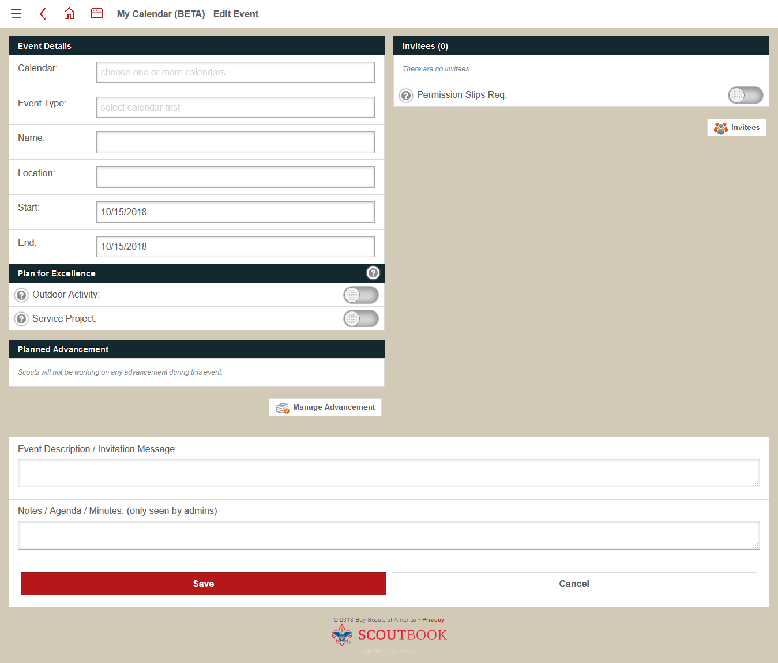

To begin, select the *Calendar* you want – you can add the event to the Pack/Troop calendar, or to a specific Den/Patrol calendar. You can then select the event type and add the name, location, dates/times, planned advancement and details. To add *Invitees* button and select the appropriate leaders, parents and scouts (who have their own Scoutbook logins) who should be invited. Only Invitees will receive reminder emails and be able to RSVP. Click *Save* to add the event to the calendar.

To Edit an existing Event, simply click the event in the calendar or in the list of events. Make the required changes and click *Save*. To Delete an event, click the event in the calendar or in the list of events. Scroll to the bottom of the Edit Event dialog and you will see a *Delete* button. Clicking that will remove the event from the calendar.

NOTE: Any Scouts/Parents added after an event has been created will not be added to the invitee list automatically – when adding a new Scout you must invite all of the Scouts again to ensure they receive reminder emails and can RSVP.

## Quick Entry Features

You can perform quick entry for all advancements as well as for service, hiking and camping logs. To perform a Quick Entry, navigate to the Den/Patrol level. Click the *Quick Entry* link towards the bottom of the page. You will get a new dialog that will allow you to select the type of Quick Entry you want to perform. Here is an example for Lions:

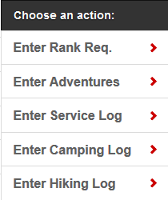

Clicking the appropriate option will bring up a new dialog, which will allow you to select the Scouts who completed the requirements or the activity, and add it to their record:

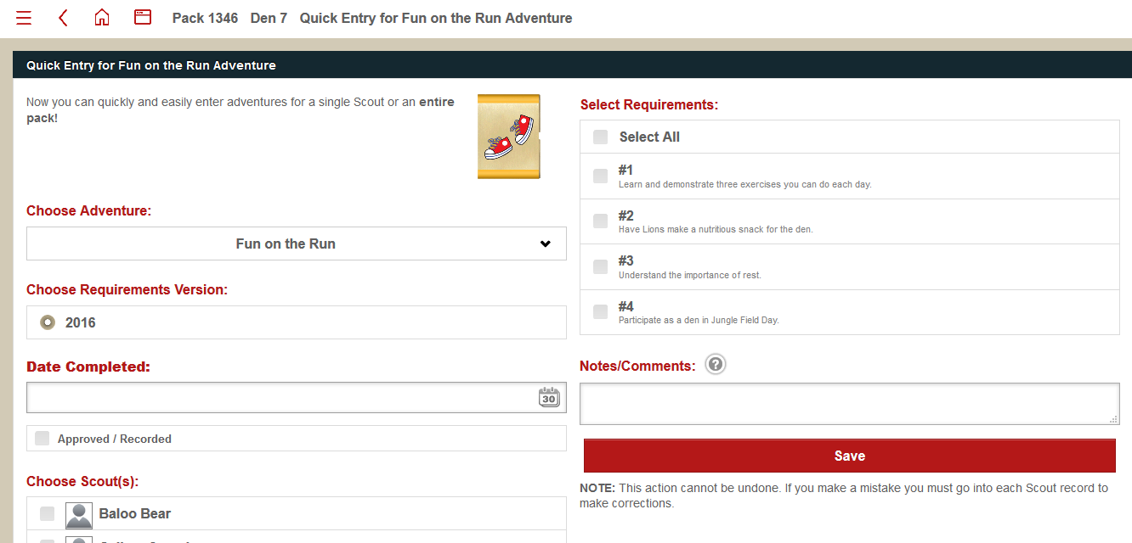

In general, there is a drop down for the Adventure/Elective, and a radio button if there are different sets of requirements. Select the appropriate options and fill in the *Date Completed* field. Selecting the *Approved/Recorded* checkbox immediately marks the requirements as approved. Below that, there will be a list of scouts in the Den/Patrol. Check the Scouts who completed the requirements, then select the Requirements that were completed in the list on the right side of the page. You can add any notes/comments (this is useful for recording the event or meeting where requirements were completed). Click *Save* to process the changes.

NOTE: If you make an error, you must go into each Scout’s record and correct the issue – unfortunately there is no “Quick Correction.”

## Creating a Den

Creating a den is straightforward for Pack Administrators. Click the *Add a Den/Add a Patrol* button from the main Pack page. This will bring up the following dialog:

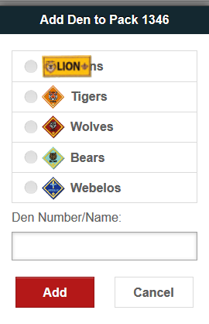

Select the level for the Den/Patrol and enter the Den/Patrol number. Click *Add* to process the changes. The new den will be empty. To add leaders and new Scouts to the Den, follow normal procedures as described in Section 3.3 and 3.4.

## Transferring a Scout between Dens

To transfer an existing Scout within the Pack/Troop to a new Den/Patrol, a Pack Admin should go to the new Den/Patrol, and click the *Reassign Scout* button. This will bring up a list of existing Scouts. Check the box next to the name of the Scout being moved, and click the *Invite* button.

NOTE: If you are not a Pack Admin, and move a Scout, this will generate an email invitation which must be accepted by the parent/Scout. Pack Admins can move the Scout without generating an email invitation.

## Advancement Sync Troubleshooting

If your Pack/Troop has advancement sync enabled, Scoutbook will restrict Scouts not shown on your official BSA roster, or who have mismatches between first name/last name/BSA number and your official BSA roster.

Scouts with Sync enabled display an A ( ) next to their name in the Pack/Troop roster and Den/Patrol roster. Scoutbook will not permit you to mark anything as approved or awarded until the Scout has sync enabled (though you can still record requirement completions and log events).

For most Scouts, Sync can be enabled by going to their profile and clicking the *Click here to activate.* link in the yellow bar below their picture:



However, in many cases, transferring Scouts will be issued a new BSA number by the receiving council. Even if they previously had a Scoutbook account, you will need to wait until they are added to your official roster and/or have received their new BSA number. To edit the Scout’s BSA number, go to their record and click *Edit Profile*. Once that is complete, you can activate sync. If there are still issues with Sync double-check that the first name/last name/BSA number are correct. If you continue to have issues, contact your Pack/Troop leadership and/or council.

## Approving/Awarding Advancements

Advancements can take a lot of effort to manage, but thankfully Scoutbook has a number of features which help reduce the burden of the process. These are accessed by clicking the *Pack Reports/Troop Reports* link for Pack Admins/Troop Admins or to the *Den Reports/Patrol Reports* link for Den Admins/Patrol Admins. The relevant reports are *Needs Approval, Needs Purchasing* and *Needs Awarding.*

### Needs Approval Report

The Needs Approval report displays all requirements marked as completed but not approved by a leader. You can click the *Approve All* button to approve all requirements shown, or click through to each Scout profile and approve all or some of the completed requirements.

### Needs Purchasing Report

The Needs Purchasing report shows all the awards that have been completed but are not marked as Awarded in Scoutbook. Scoutbook will generate a Purchase Order(PO) for the Scout Store – and you can add items to the PO from this report. You can choose to select all of the awards to be added to the PO or only some (in the case where you have stock on hand). There can only be one open PO at a time. If no PO is currently open, select the awards to add to the PO and click the *Create New Purchase Order* button. If a PO is open, the process is the same, but the button text will read *Add to Open Purchase Order*.

The Open PO can be printed or exported by clicking on the open PO at the bottom of the page, and closed PO’s can be browsed at the bottom of the page. The PO’s can be organized by Den

### Needs Awarding Report

The Needs Awarding report shows all the awards that have been completed but are not marked as Awarded in Scoutbook. You can select to mark all awards as awarded or individually select profiles/awards to be marked as Awarded from this report. If not added to a PO, marking an award as Awarded will prevent it from being added to a PO.

## Report Builder

In the *My Dashboard* view when you first login to Scoutbook, you’ll see a *Reports* link. If you click that, the list will expand and you’ll see a *Report Builder* link. This allows you to generate reports using the data stored in Scoutbook. It’s particularly useful for viewing progress towards Advancement. When you open the report builder, you’ll get a dialog that allows you to choose to run the report on *All* Scouts in the Pack or Troop, or *Custom* (by Den or individually). You can then select the data to include in the report – which includes everything from basic profile information to progress towards requirements for the next rank. These reports can be saved and added to the *Reports* link in *My Dashboard.*